* **Encryption:**
* Program Code:

import java.util.Scanner;

public class CaesarCipherJava {

public static void main(String...s){

String message, encryptedMessage = "";

int key;

char ch;

Scanner sc = new Scanner(System.in);

System.out.println("Enter a message: ");

message = sc.nextLine();

System.out.println("Enter key: ");

key = sc.nextInt();

for(int i = 0; i < message.length(); ++i){

ch = message.charAt(i);

if(ch >= 'a' && ch <= 'z'){

ch = (char)(ch + key);

if(ch > 'z'){

ch = (char)(ch - 'z' + 'a' - 1);

}

encryptedMessage += ch;

}

else if(ch >= 'A' && ch <= 'Z'){

ch = (char)(ch + key);

if(ch > 'Z'){

ch = (char)(ch - 'Z' + 'A' - 1);

}

encryptedMessage += ch;

}

else {

encryptedMessage += ch;

}

}

System.out.println("Encrypted Message = " + encryptedMessage);

}

}

* Output:

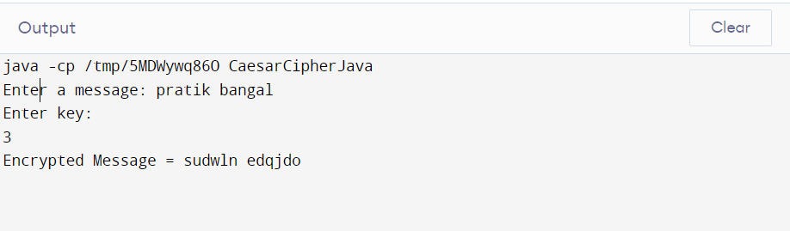

* **Decryption:**
* Program Code:

import java.util.Scanner;

public class CaesarCipherJava {

public static void main(String...s){

String message, decryptedMessage = "";

int key;

char ch;

Scanner sc = new Scanner(System.in);

System.out.println("Enter a message: ");

message = sc.nextLine();

System.out.println("Enter key: ");

key = sc.nextInt();

for(int i = 0; i < message.length(); ++i){

ch = message.charAt(i);

if(ch >= 'a' && ch <= 'z'){

ch = (char)(ch - key);

if(ch < 'a'){

ch = (char)(ch + 'z' - 'a' + 1);

}

decryptedMessage += ch;

}

else if(ch >= 'A' && ch <= 'Z'){

ch = (char)(ch - key);

if(ch < 'A'){

ch = (char)(ch + 'Z' - 'A' + 1);

}

decryptedMessage += ch;

}

else {

decryptedMessage += ch;

}

}

System.out.println("Decrypted Message = " + decryptedMessage);

}

}

* Output:

